**SWE 645 Assignment 3**

**Team Members:**

Amulya Jaladi [G01394922]

Rakesh Badam [G01381556]

Sai Kumar Reddy Ambati [G01381823]

Guru Dwaraka Tej Vandavasi [G01380462]

### 

### Link to Rancher:

Get request:

### <https://3.91.176.108/k8s/clusters/c-m-fffcrl9g/api/v1/namespaces/default/services/http:deploy1:8080/proxy/surveylist>

### Post request:

<https://3.91.176.108/k8s/clusters/c-m-fffcrl9g/api/v1/namespaces/default/services/http:deploy1:8080/proxy/s>

**Creation of RDS on amazon Console**

* **Db creation on AWS:**

1. Select RDS in Amazon console:

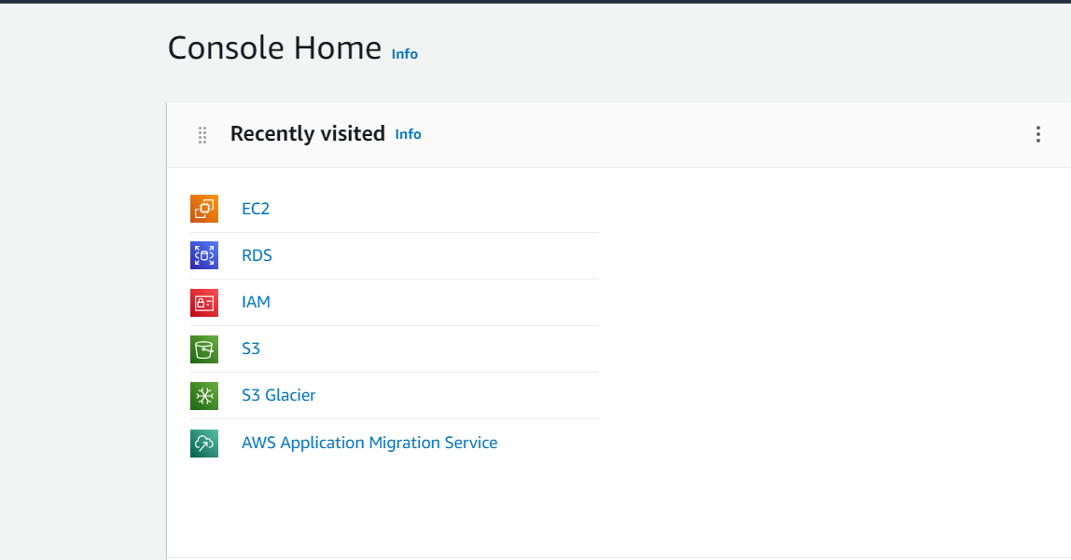

1. Select Create Database:

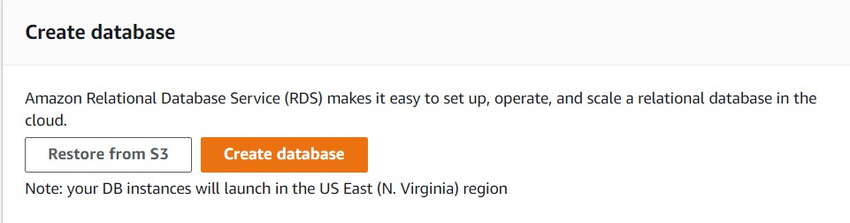

1. Create Database:

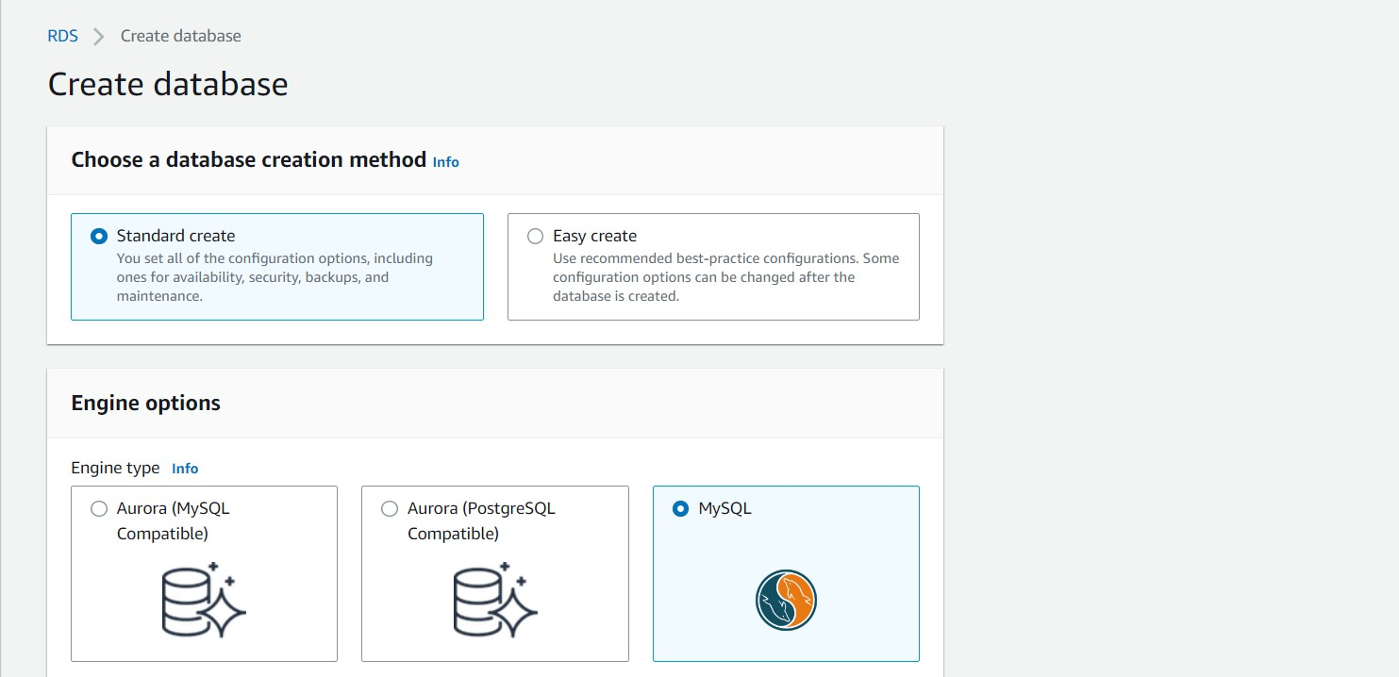

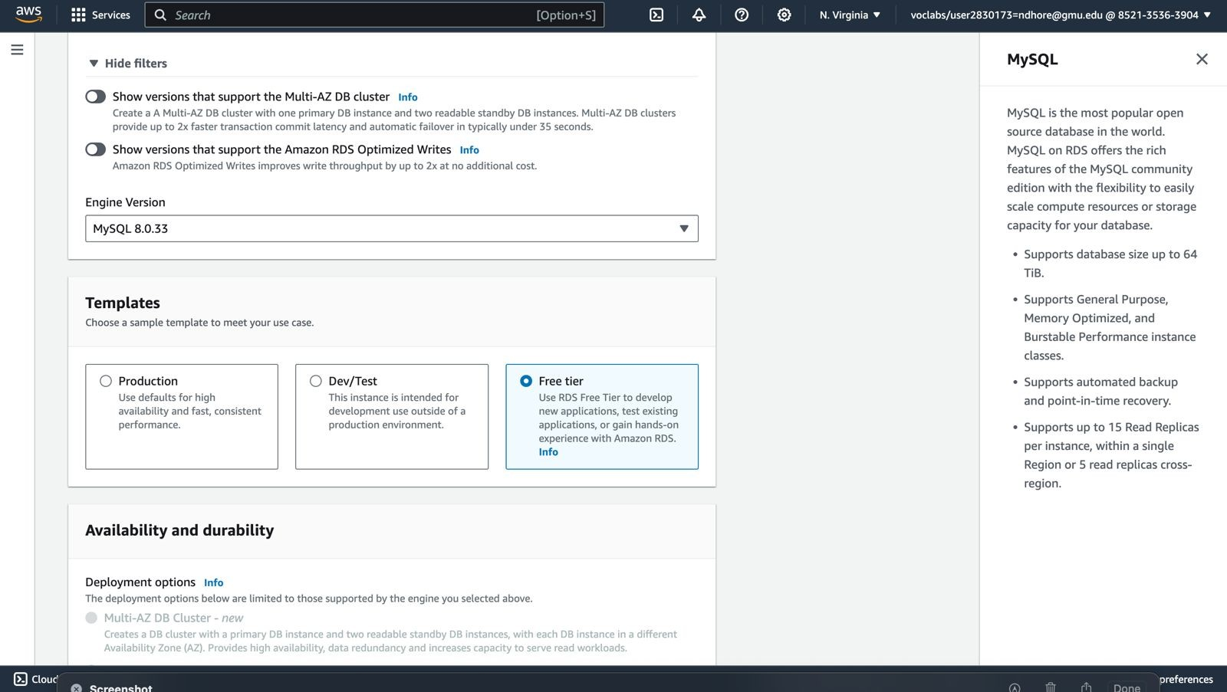

1. 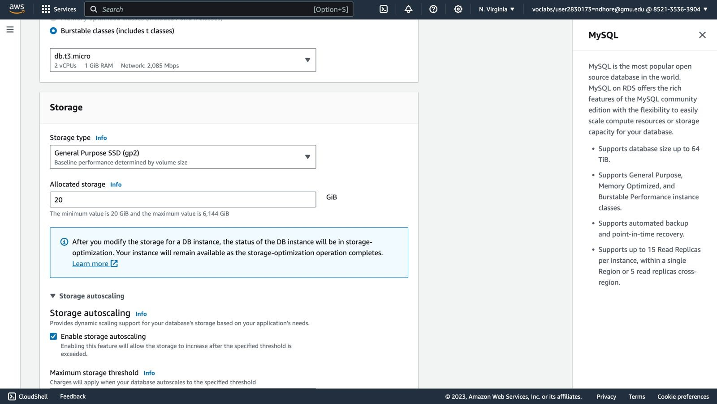Configure CPU and storage type
2. Configure connectivity

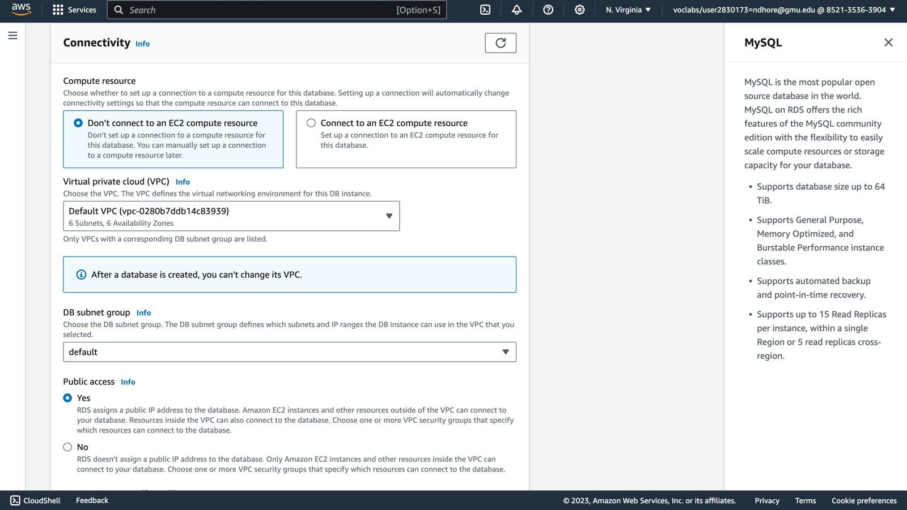

1. Create new VPC

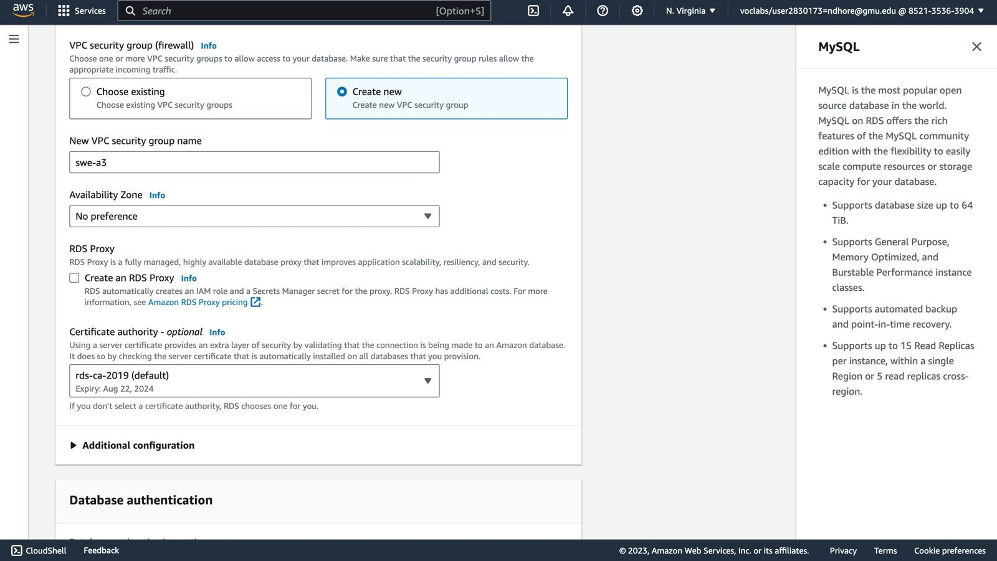

1. Configure Database options
   1. DB name: dbsurvey

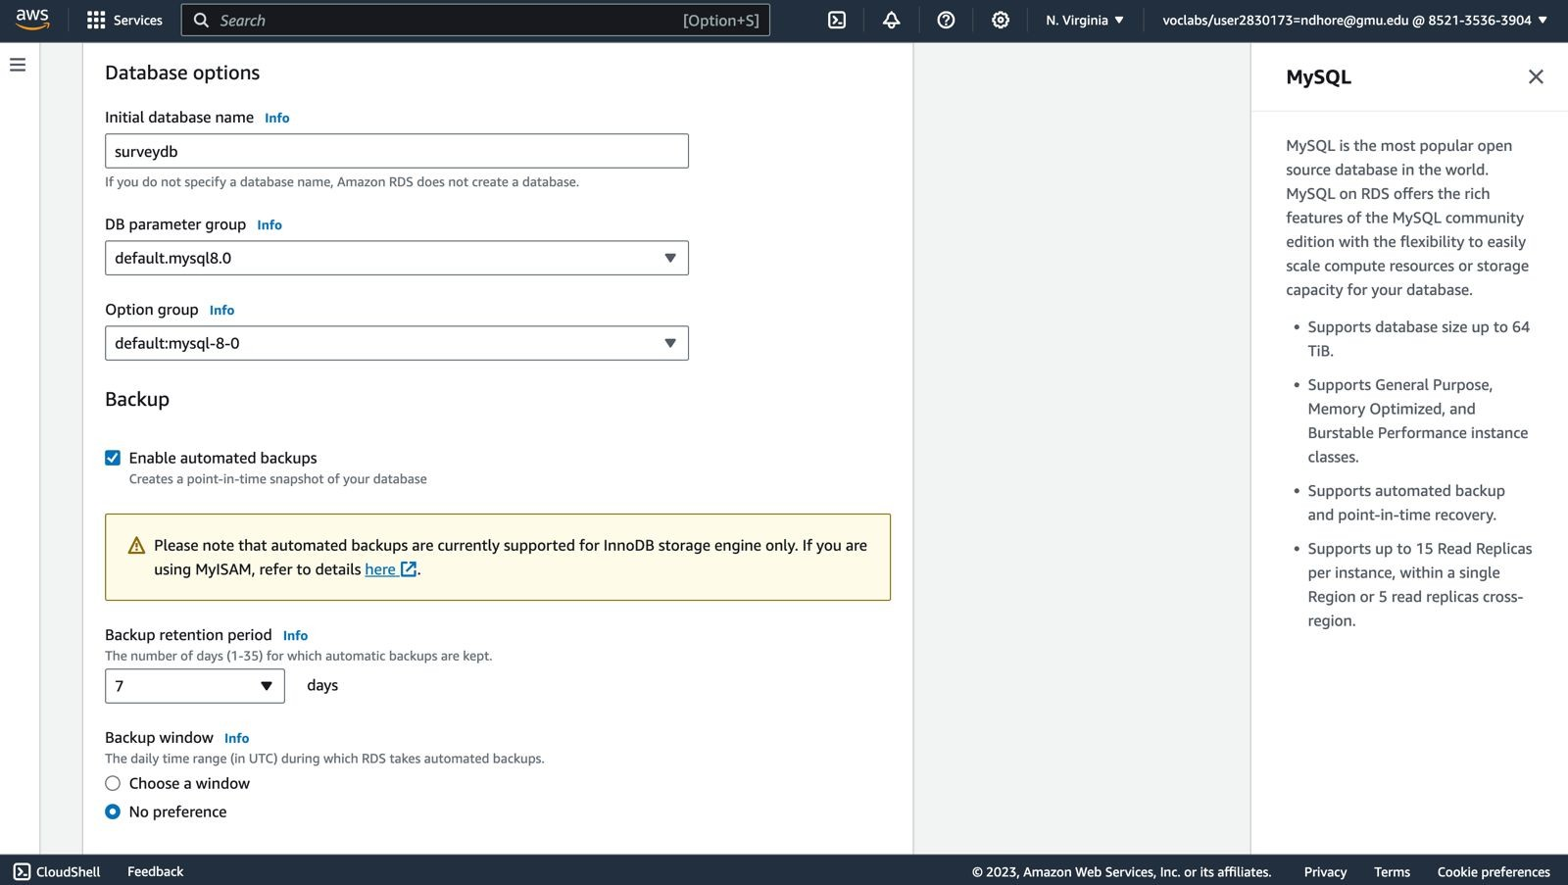

* 1. 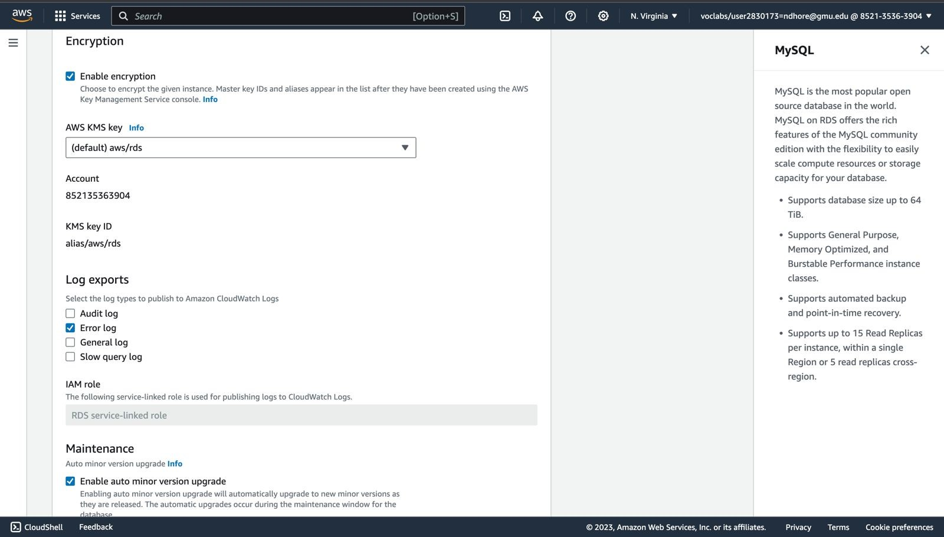

1. Create Database
2. Once Initialization is done, we get an endpoint for our database  [swedb.cktrej26lnpy.us-east-1.rds.amazonaws.com](http://swe-a3-db.cigg020847fv.us-east-1.rds.amazonaws.com/)

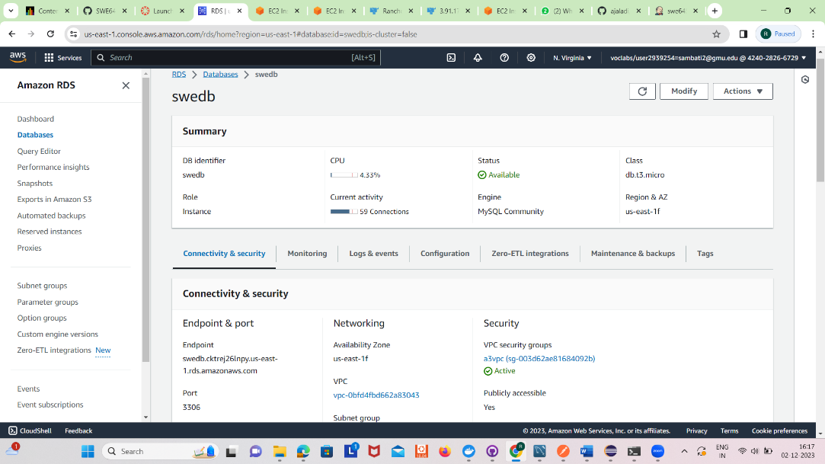

1. Now configure the Security groups so that we can access the database from Eclipse IDE

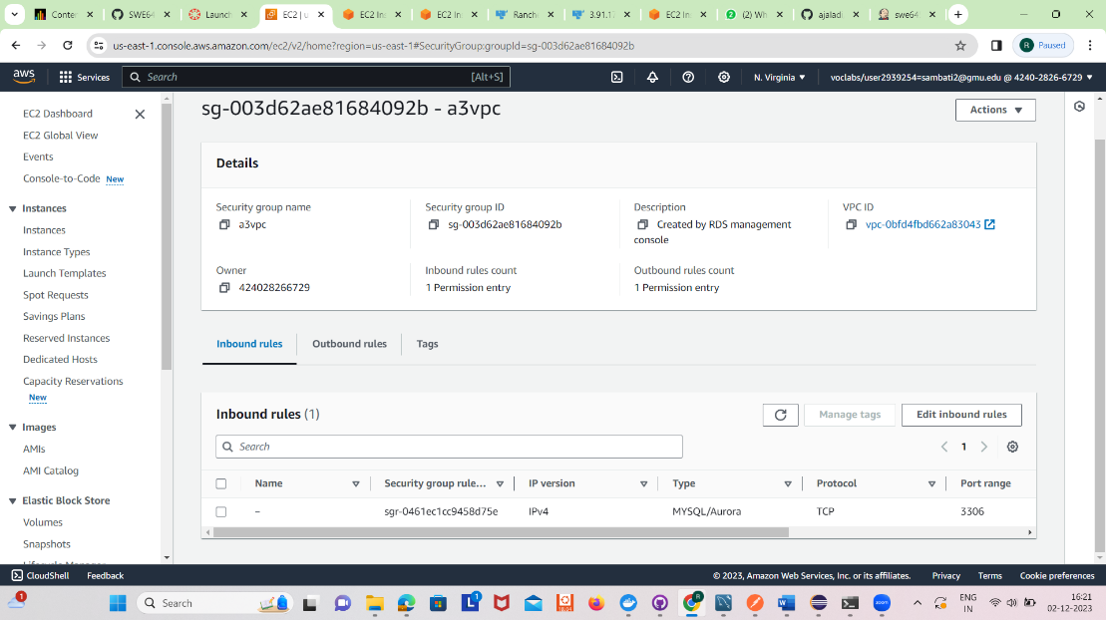

# **Connecting RDS Mysql database using MySQL workbench**

1. Create a new connection in mysql workbench.

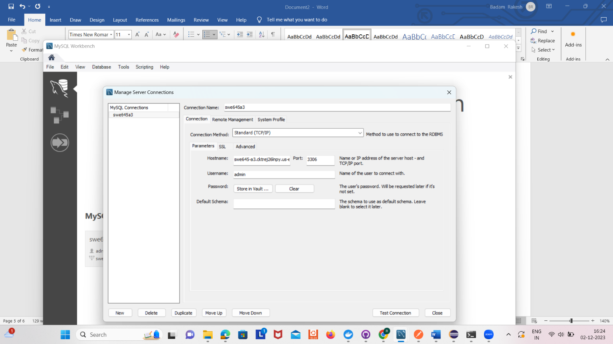

1. Now create tables required for our project.

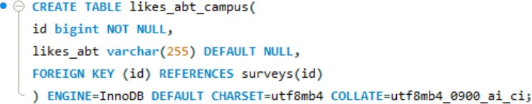Surveys and likes_abt_campus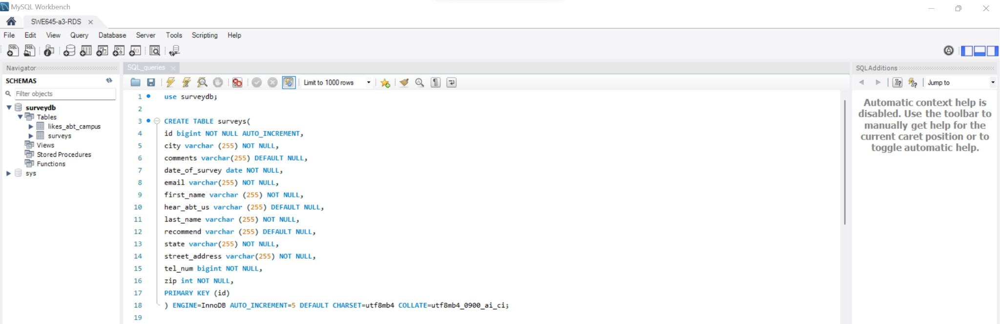

**Creating a Java Maven Project:**

First create a maven project from <https://start.spring.io/> Then import it to eclipse.

We have implemented the spring-boot based APIs and the build the jar file for the project.

Once the project is build the jar file is created in target folder of the project.

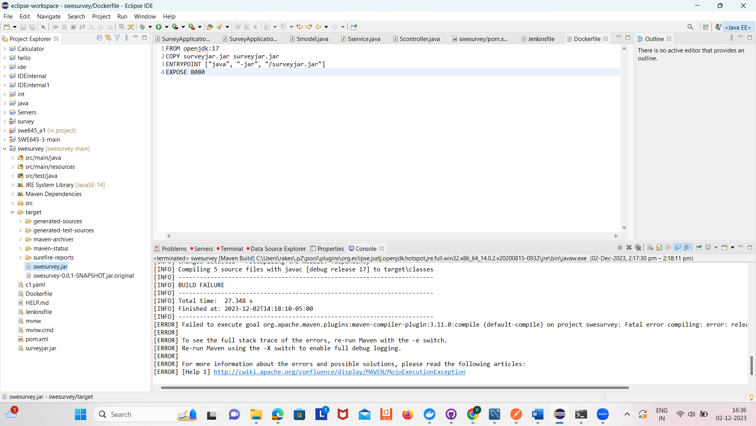

Now push it to the git repository

<https://github.com/ajaladi/swesurvey>

We have run the project and tested it locally on postman tool.

Posting Surveys: (Testing Locally)

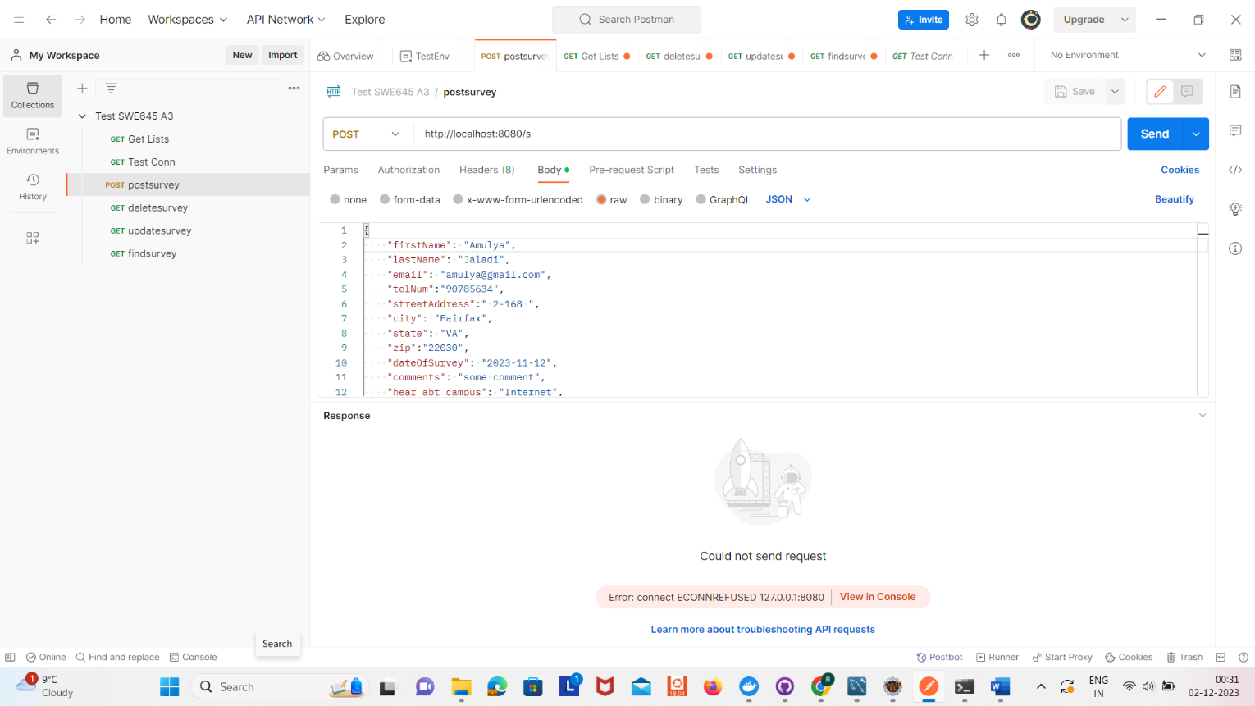

Now create a Dockerfile



Run following commands to build and push the docker image

*docker build --tag surveyjar .*

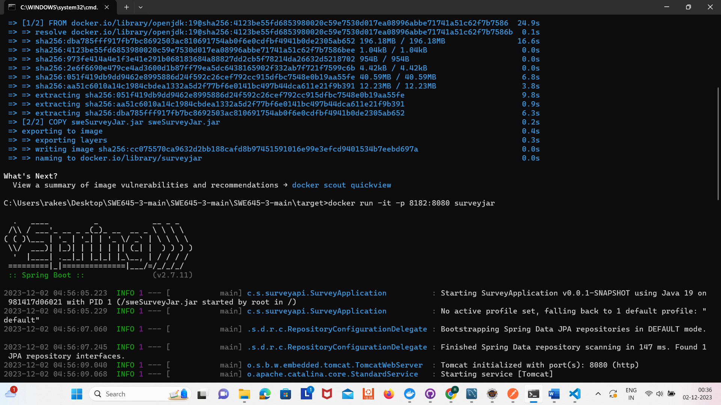

*docker run -it -p 8182:8080 surveyjar*

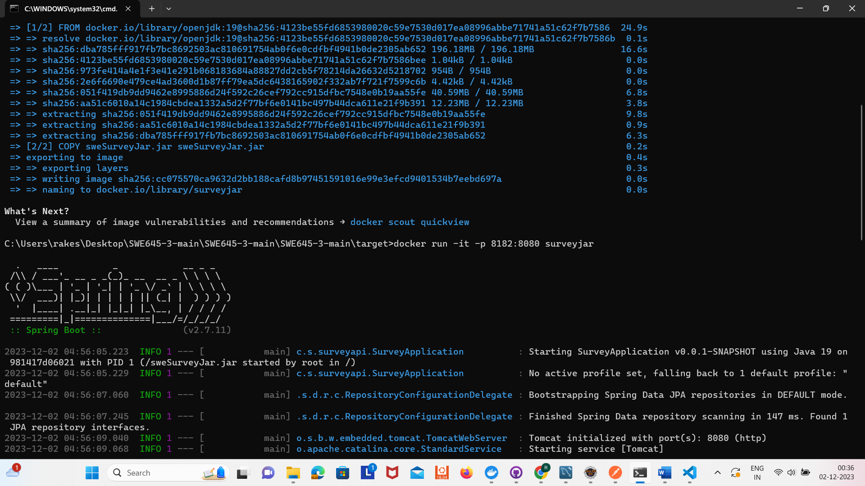

We can test at http://localhost:8182/surveylist

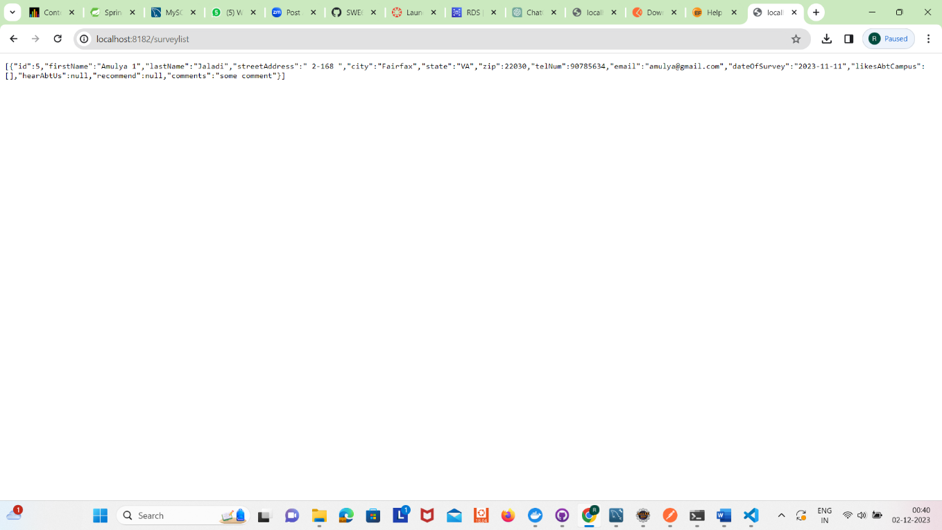

*docker login -u amulyajaladi*

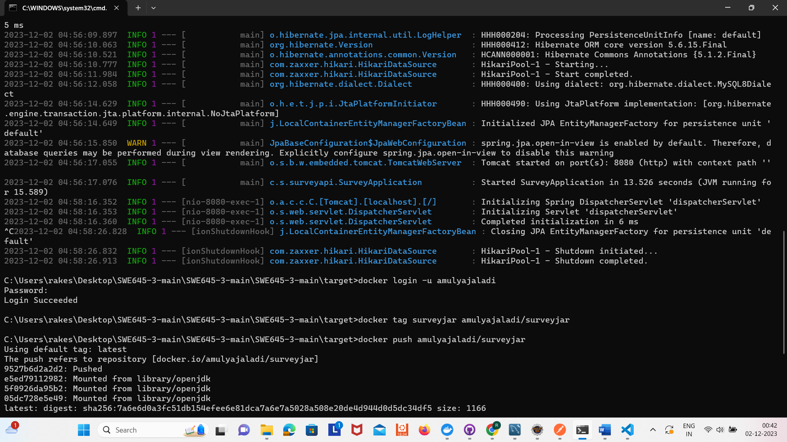

*docker tag surveyjar amulyajaladi/surveyjar*

*docker push amulyajaladi/surveyjar*

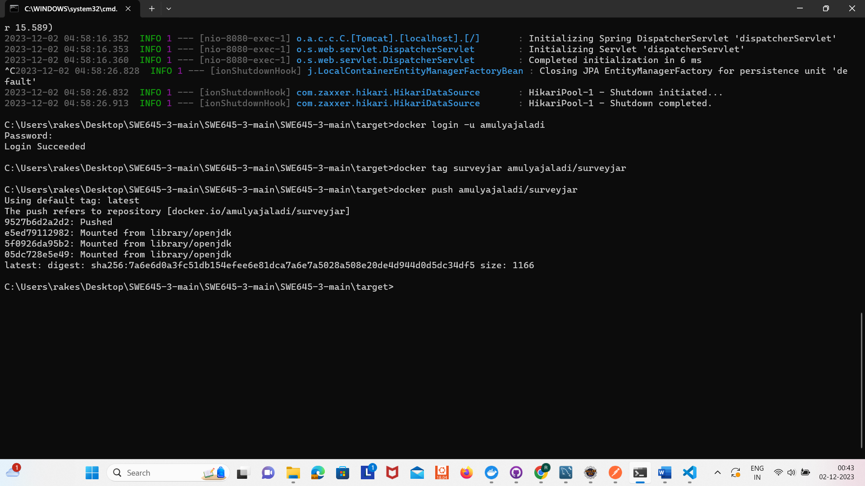

**Installing rancher and Kubernetes on EC2 instances:**

Create EC2 – Rancher (t2.medium), K8s (t2.large), Jenkins (t2.large)

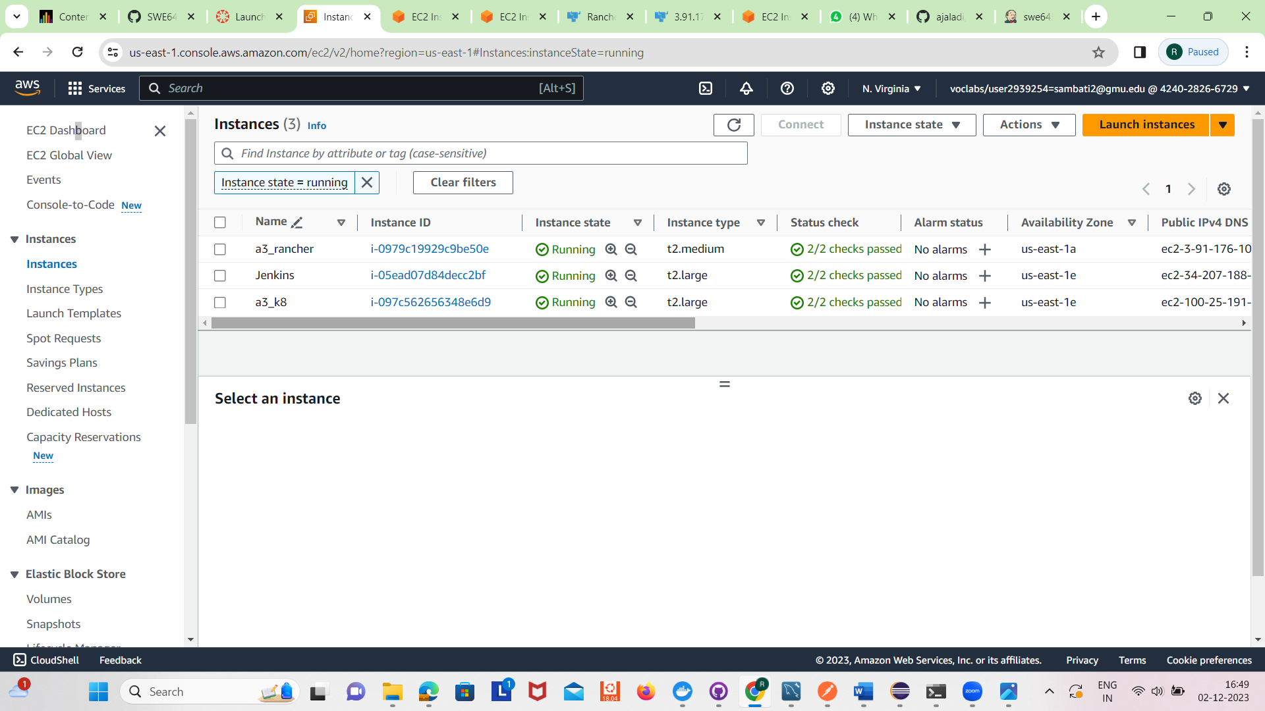

On Rancher run the following commands:

*Sudo su –*

*sudo apt-get update*

*sudo apt install docker.io*

*docker run --privileged -d --restart=unless-stopped -p 80:80 -p 443:443 rancher/rancher*

*docker ps*

Now Go to AWS console and open IPv4 of rancher machine ([https:// 3.91.176.108 /](https://44.210.59.29/))

Run below command in rancher EC2 (This will give password)

*docker logs container-id 2>&1 | grep "Bootstrap Password:"*

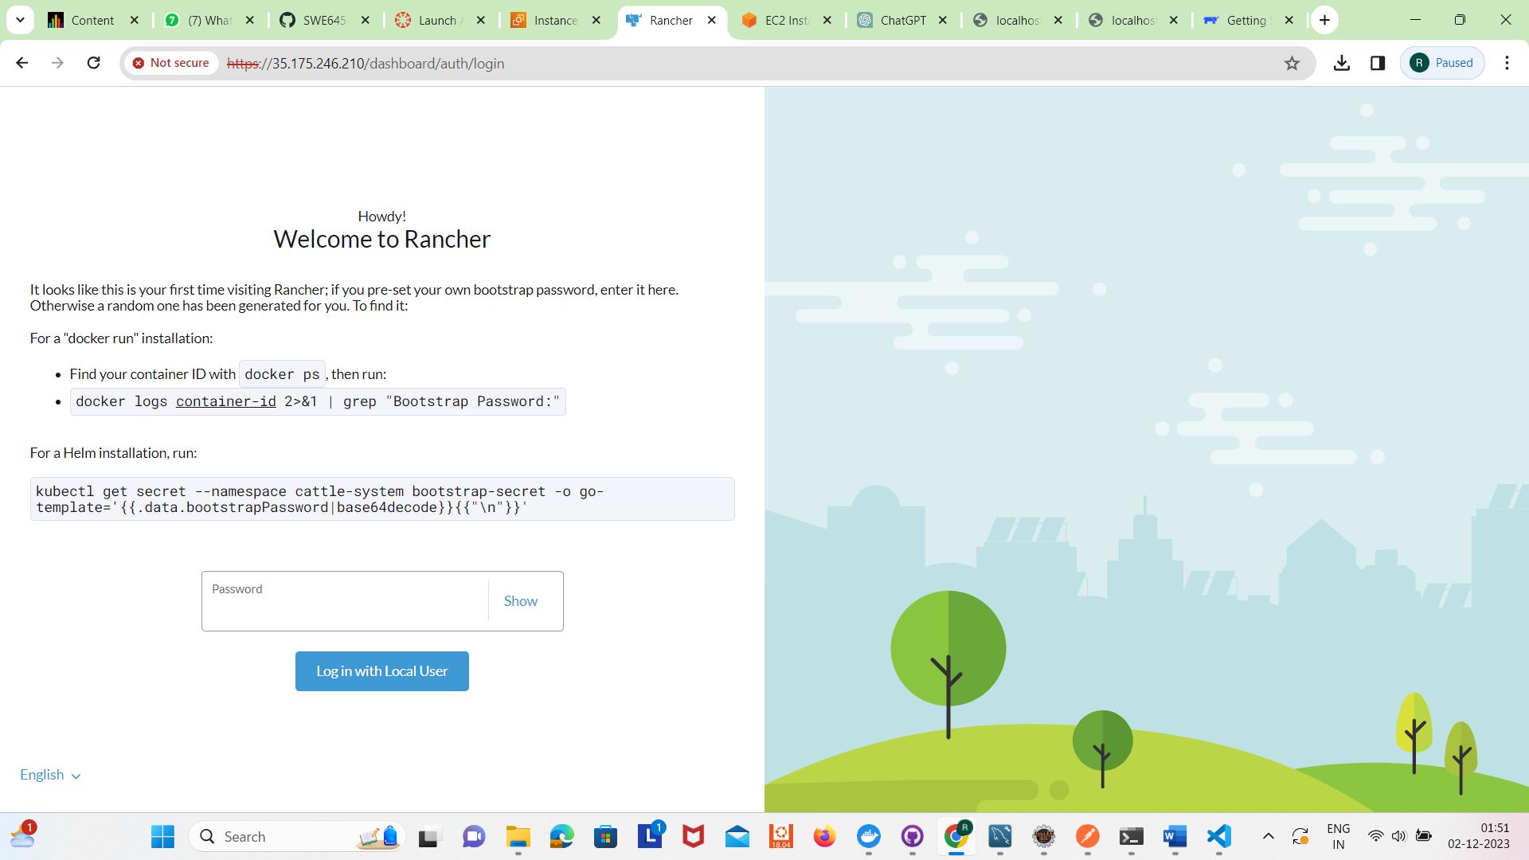

Then copy the password and go to rancher UI, then log in and create your own password (adminadminadmin)

In Parallel connect to K8s instance and run below commands:

*Sudo su –*

*sudo apt-get update*

*sudo apt install docker.io*

Now in Rancher website create a custom cluster and copy insecure command which is shown once created.

Run that command in K8s instance. Then cluster will be active.

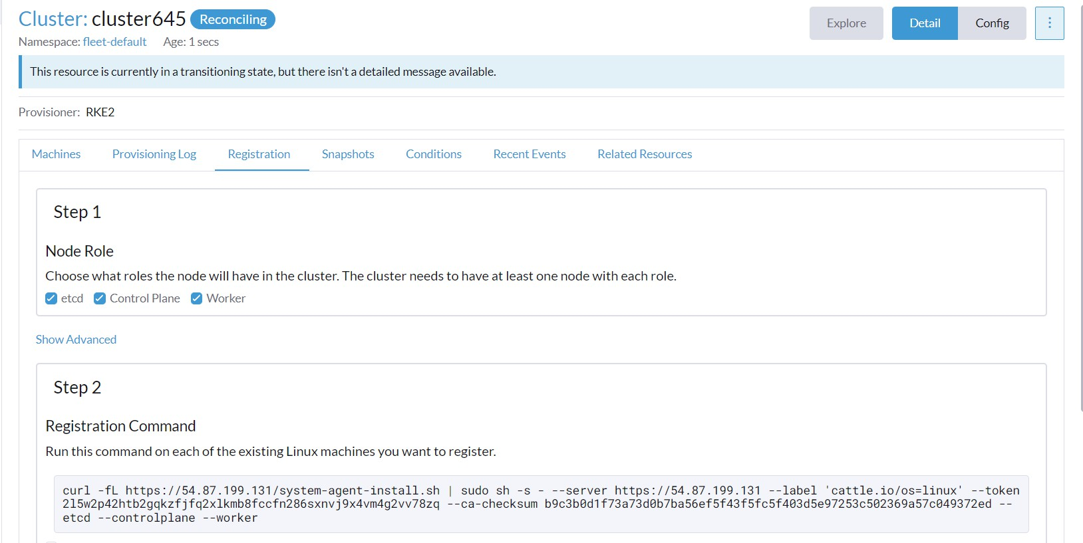

Now cluster will be created

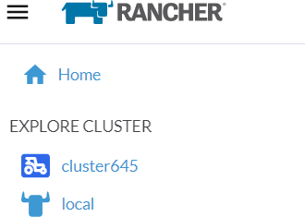

Create the pods in deployment

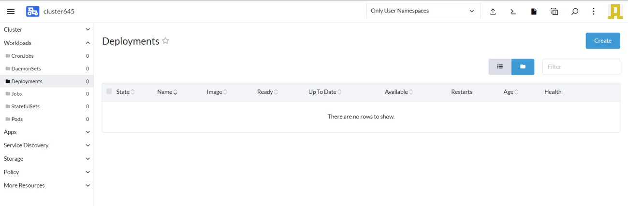

Create a pod

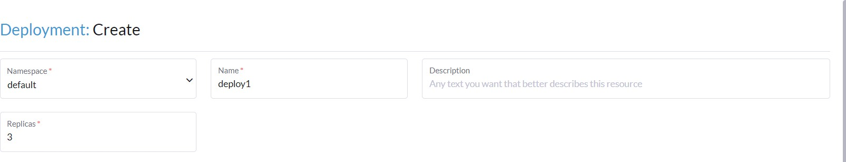

Give the container image

*surveyjar/amulyajaladi:latest*

Add the nodeport

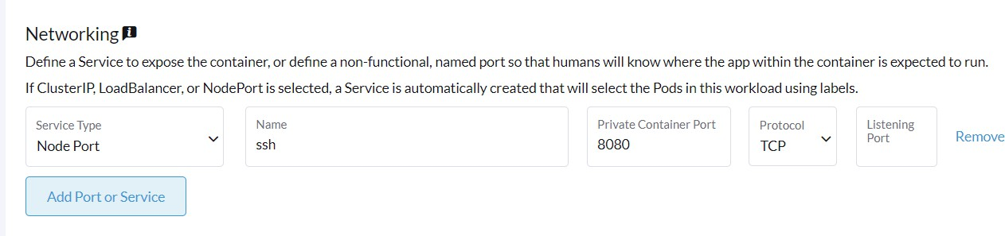

Pods will be in running state.

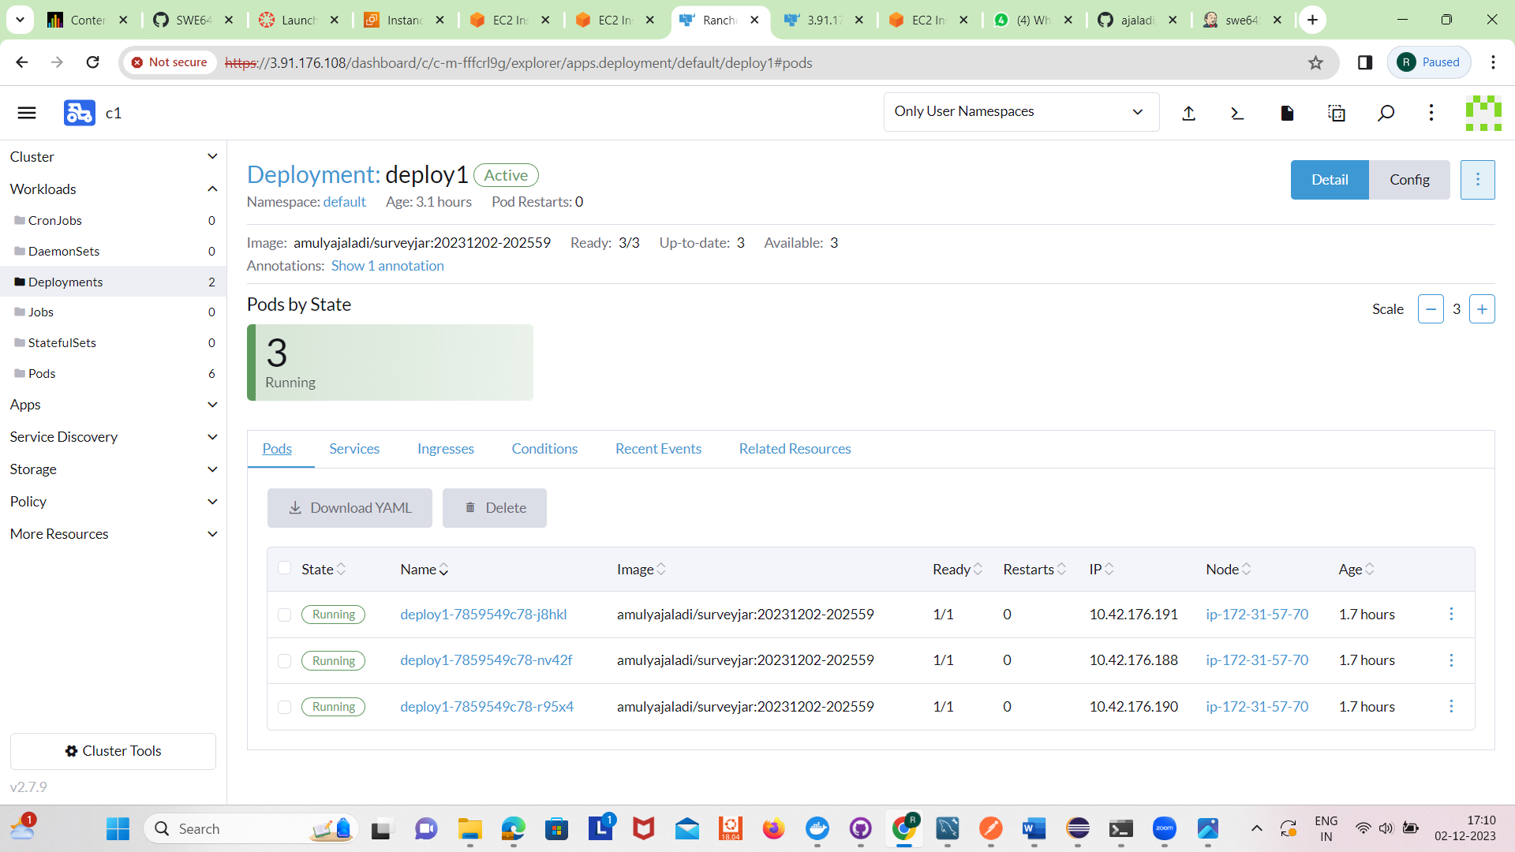

Under services we can see deployments along with port

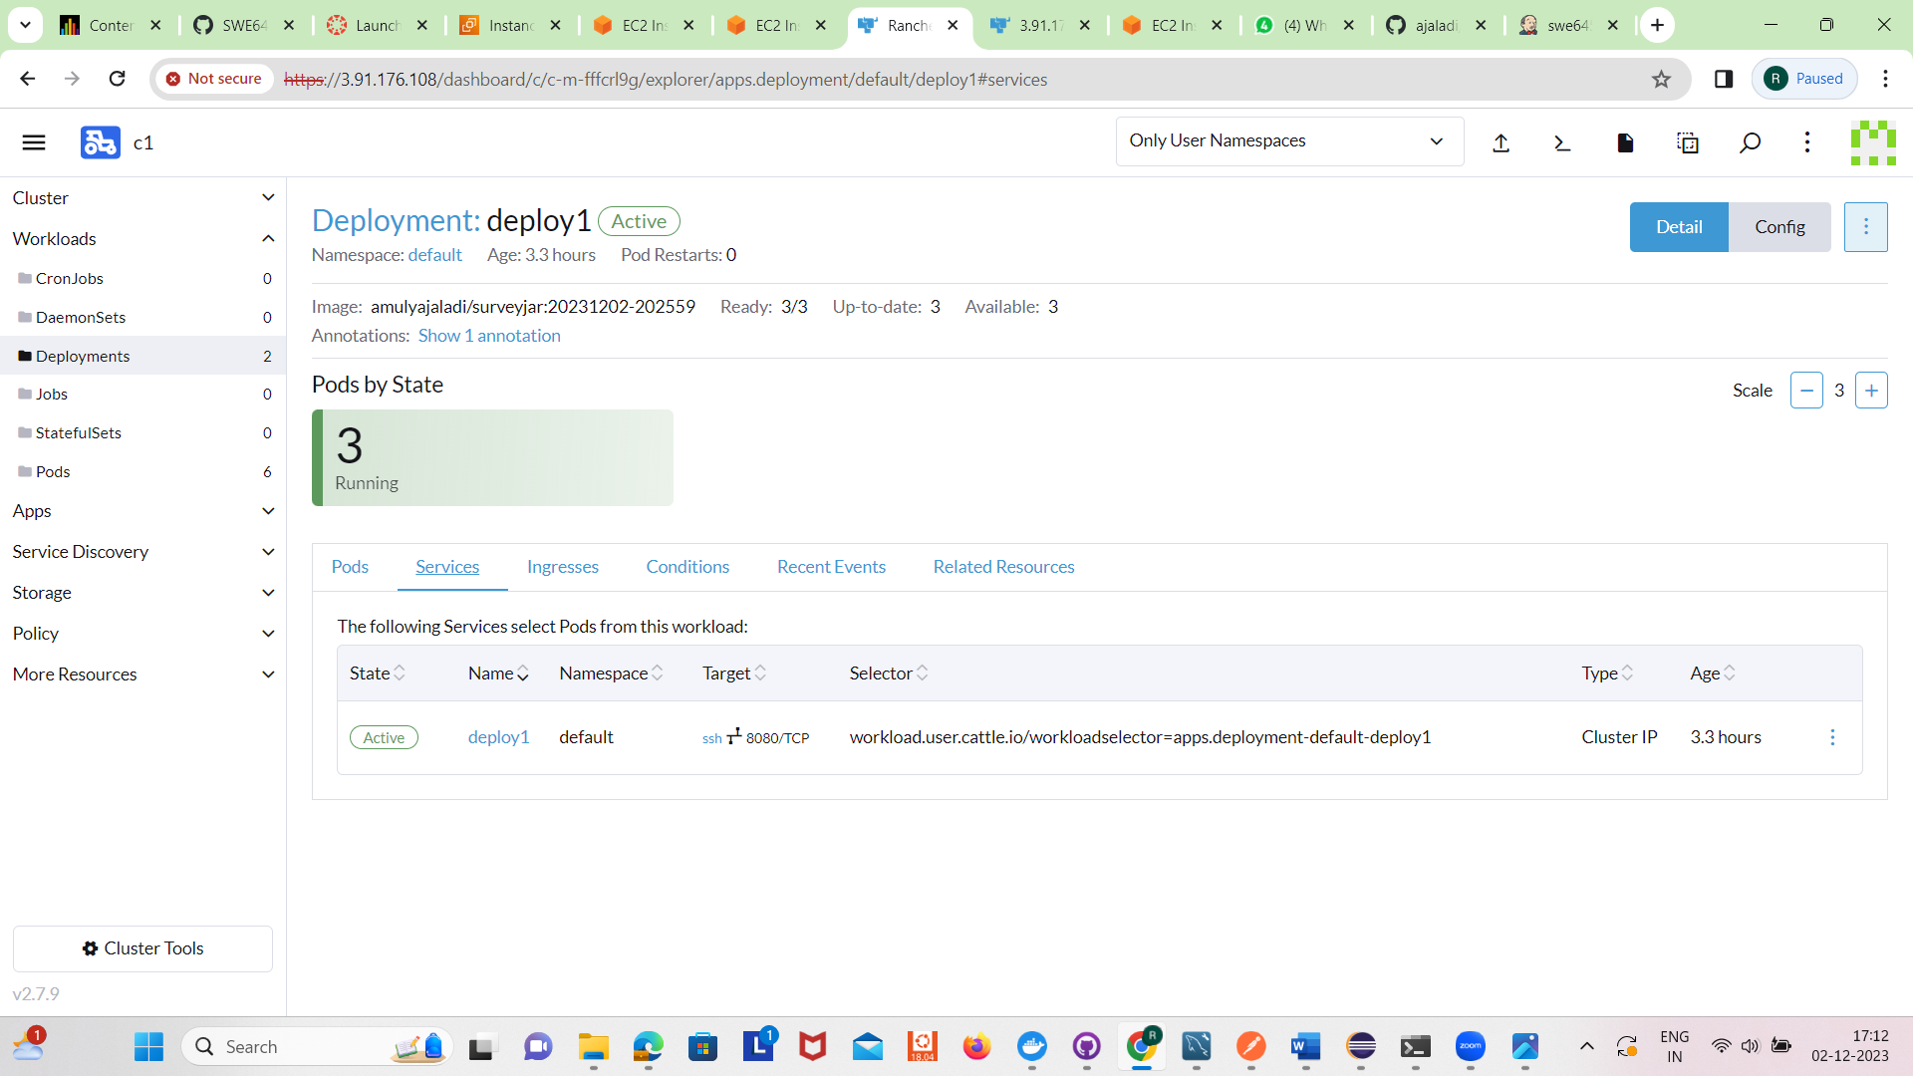

Now we can test the GET call of the surveys

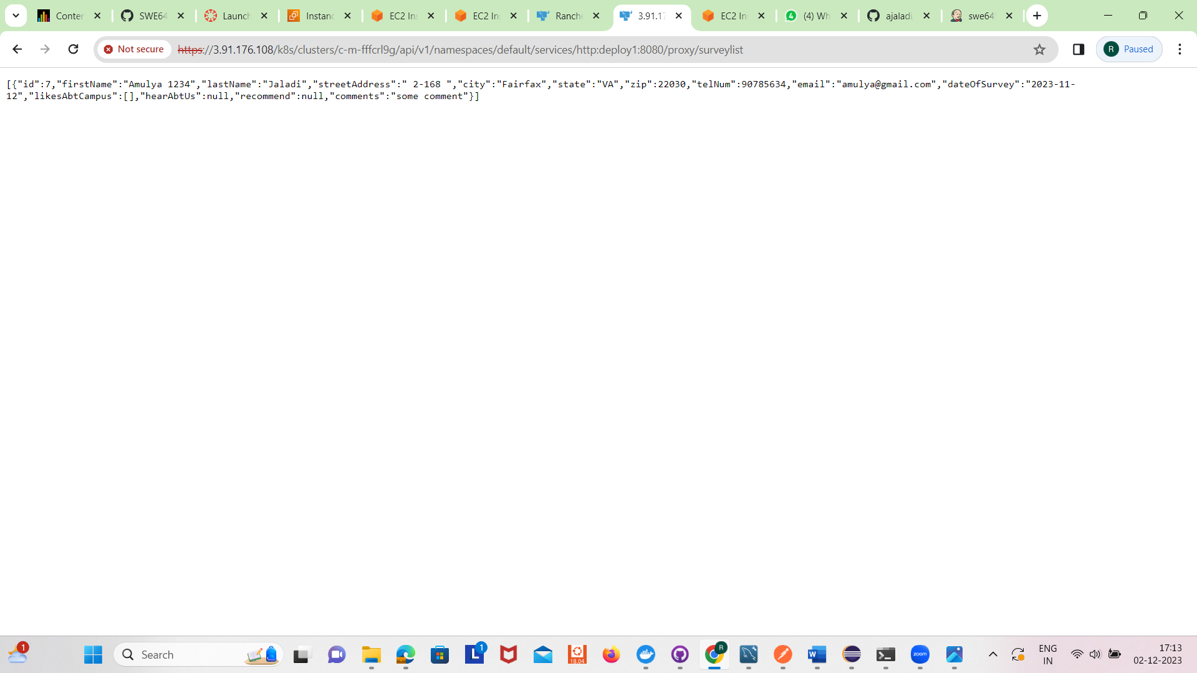

Now create a Jenkins EC2 instance and connect to it.

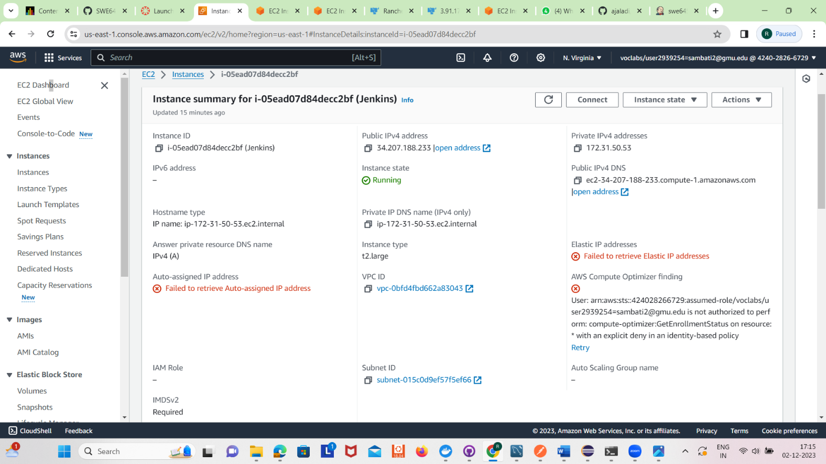

Run the following commands :

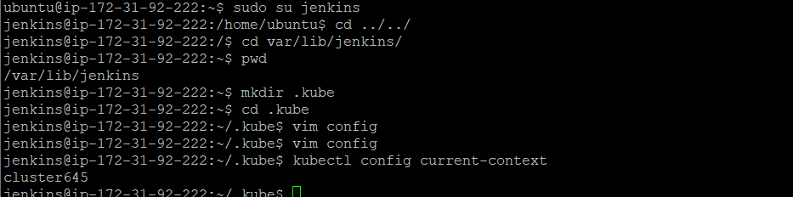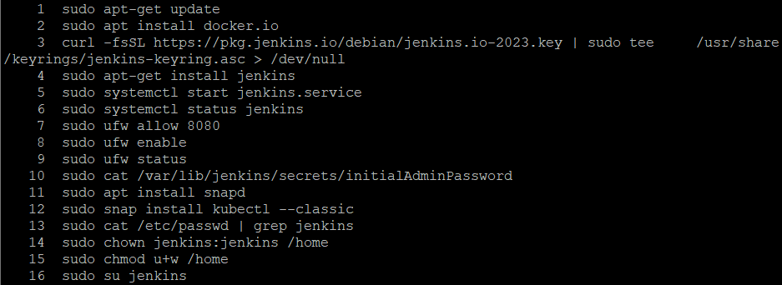

Install necessary plugins

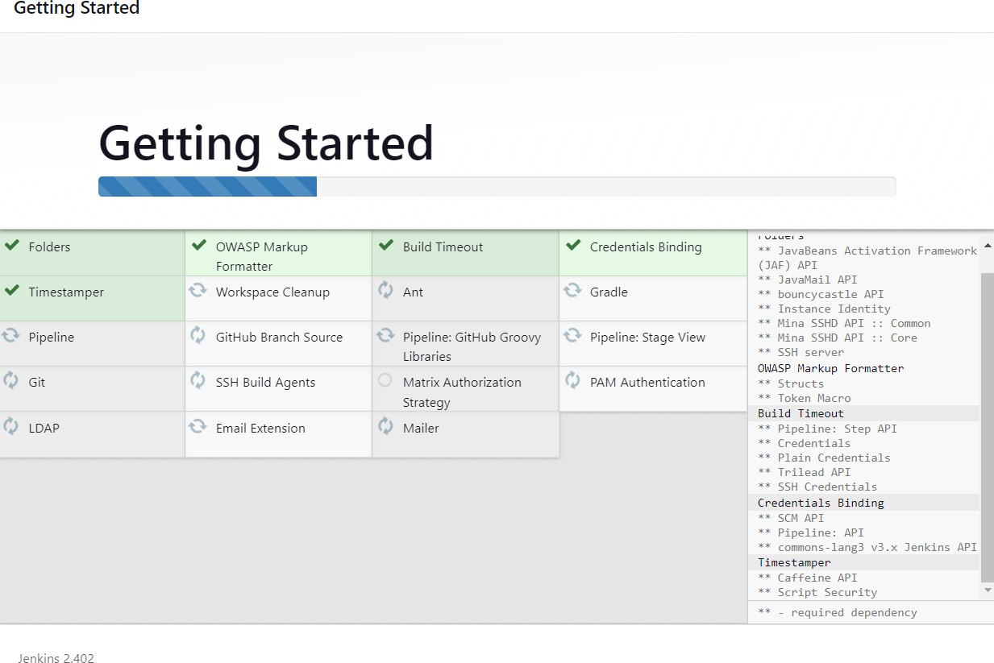

In the dashboard -> Go to manage Jenkins -> plugins -> available plugins

Select as shown below

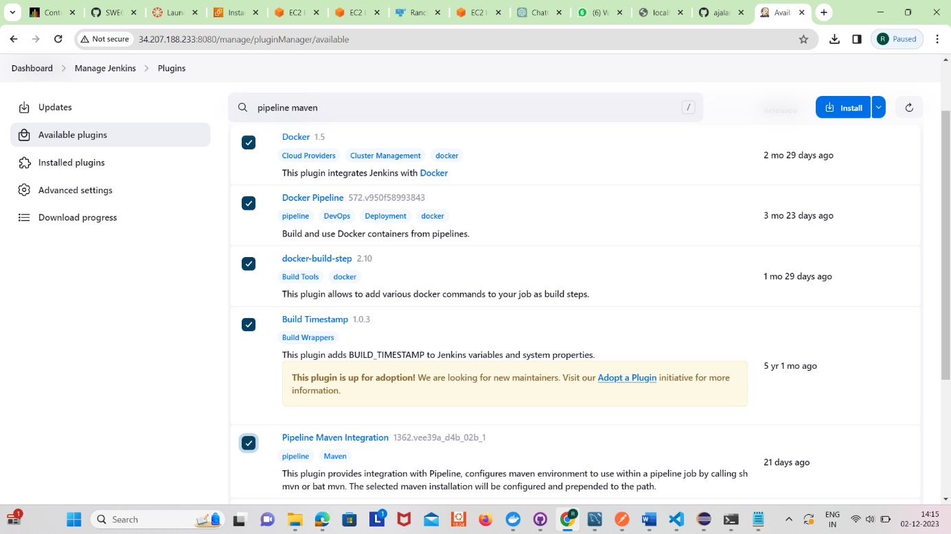

Add the credentials for Github, Docker in the below path

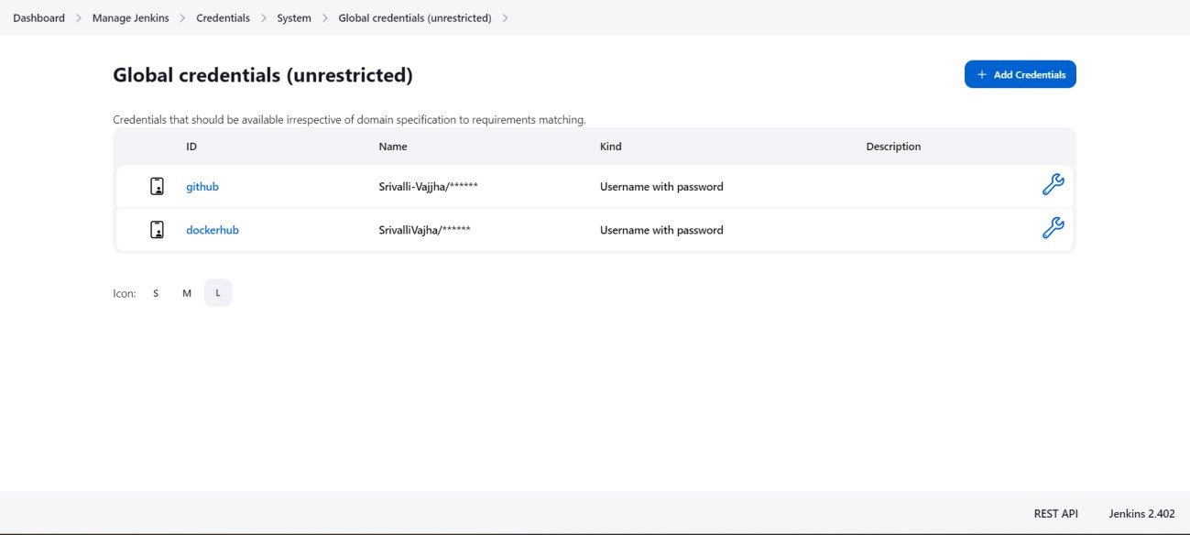

Build the pipeline

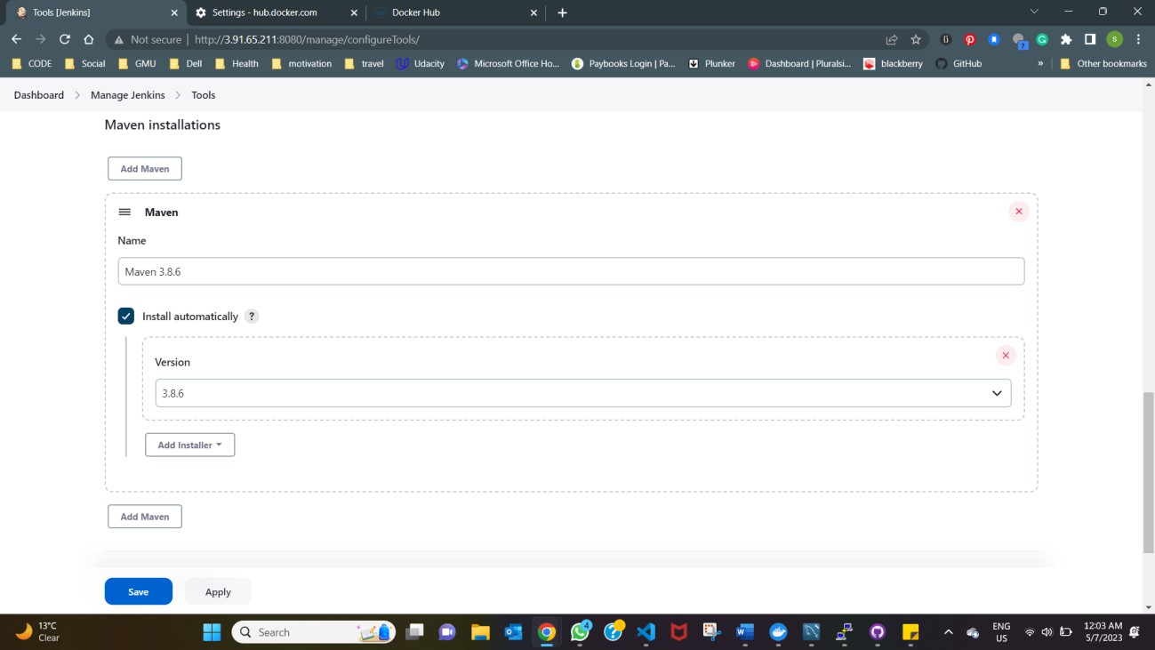

The pipeline should be successfully built

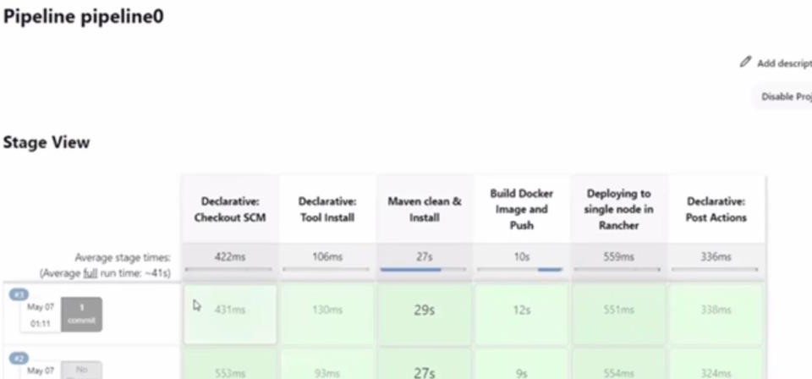

Now the ci/cd pipeline is built. Next step is to test in postman.

**Testing in Postman**

To test in Postman, since the IP address is in https, we need to add authentication API keys in Rancher.

In the rancher dashboard, go to account-> Click “Create API key”

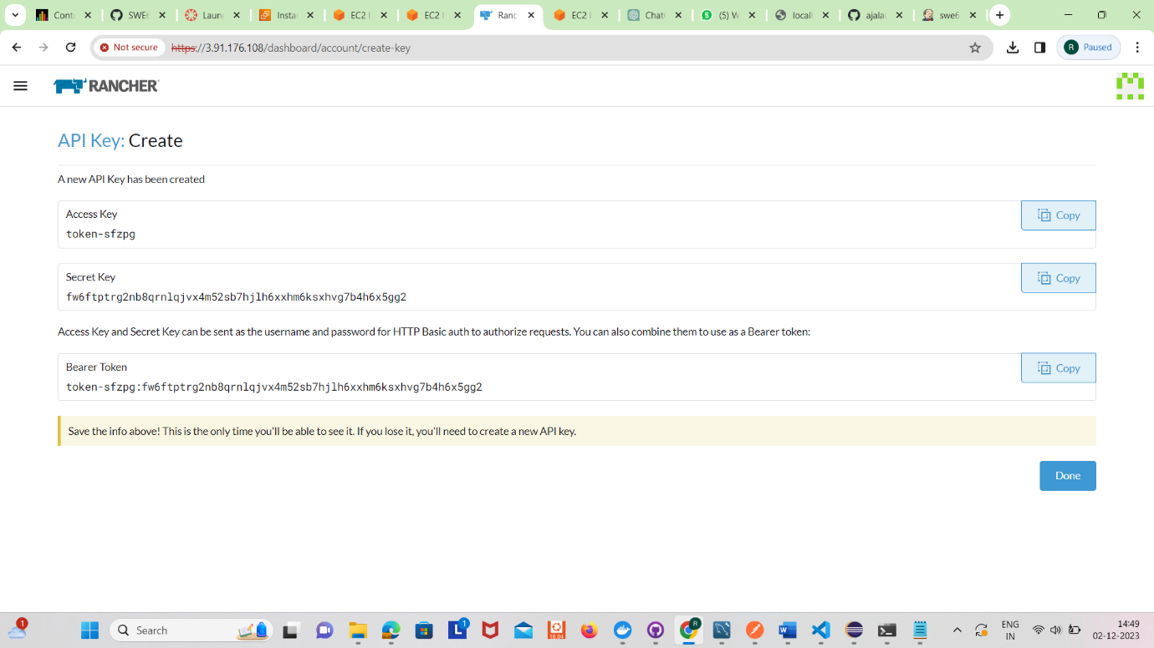

Copy this Bearer token, and paste it into the postman’s authorization section of a new request

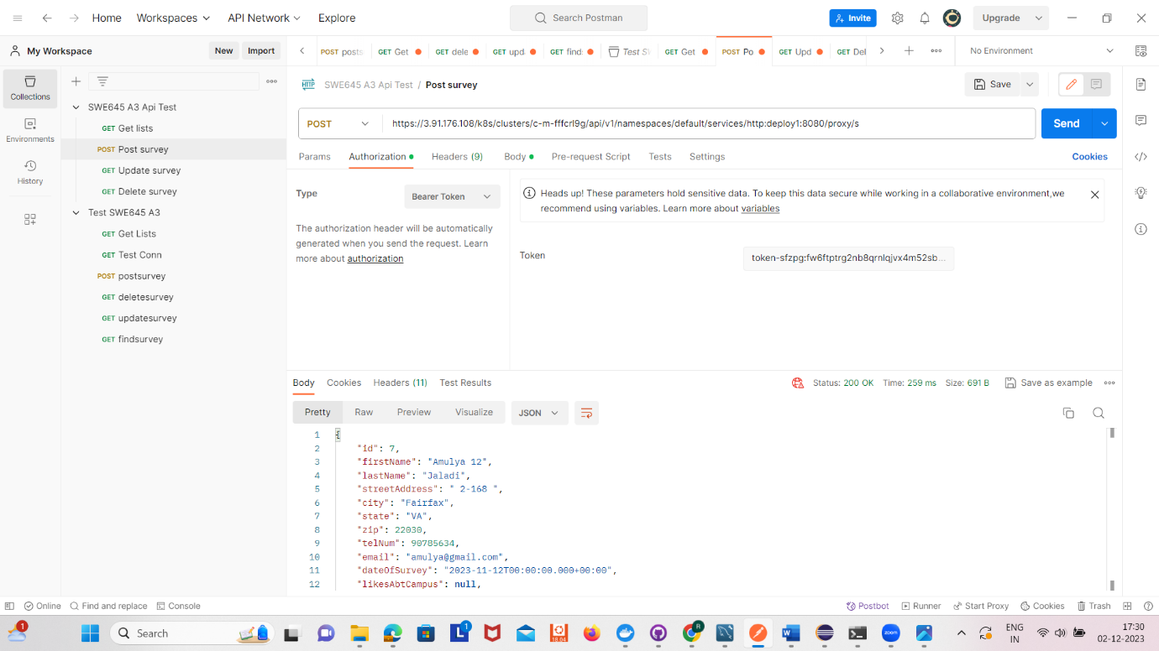

Post an entry in survey.

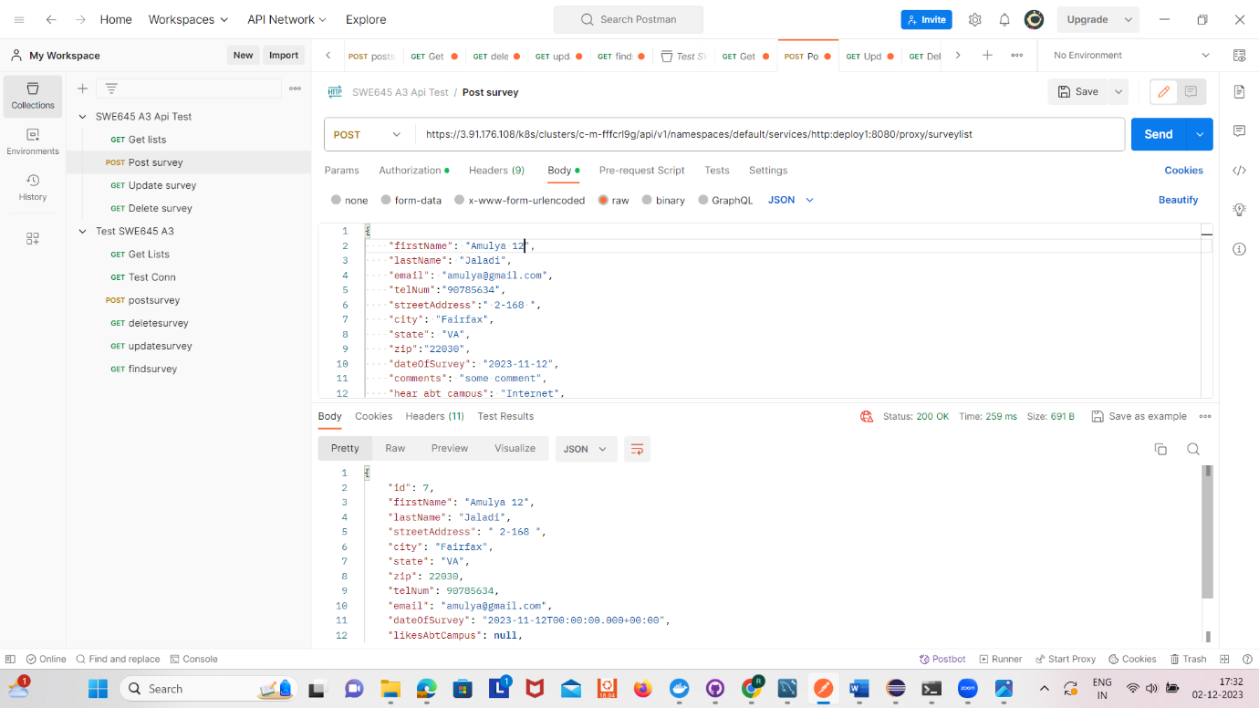

Retrieving all the entries of survey.

